
Department of Artificial Intelligence & Machine Learning
Assignment 1 – Data Visualization Lab

Name: Pavan Bhapkar
PRN: 24070126137
Batch: AIML 24-28 B3

Beyond Power BI: Exploring Modern Data Visualization Tools
Introduction
Visualization of data is an integral part of data analysis through which one can make sense out of the data. Although Microsoft Power BI is one of the most commonly used Business Intelligence (BI) software owing to its interactive dashboards and enterprise capability, there are a number of other visualization softwares available having some features making them fit for other requirements.
In this blog, we will discuss five such commonly used visualization softwares: Tableau, Python (Seaborn), Microsoft Excel, Google Looker Studio, and Flourish Studio. We will compare these softwares with Power BI. The comparison will be based on visualization done using real world datasets in each of the software.
- Tableau
History
Tableau was founded in 2003 as a result of research conducted at Stanford University. It quickly gained popularity because of its drag-and-drop interface and powerful visualization capabilities. In 2019, Tableau was acquired by Salesforce, further expanding its presence in enterprise analytics.
Dataset Used
For tableau I have used the video games sales dataset on Kaggle. Itcontains sales information for thousands of video games released across multiple gaming platforms. It includes details such as the game title, publisher, genre, release year, platform, and regional as well as global sales figures. This dataset is widely used for analyzing market trends, publisher performance, genre popularity, and the commercial success of video games.
Visualization
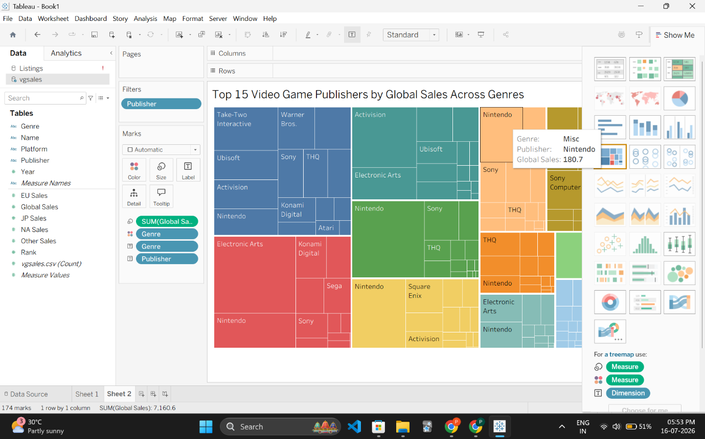Comparison with Power BI
Tableau and Power BI are among the leading Business Intelligence tools. While Power BI integrates seamlessly with Microsoft products and offers a cost-effective solution for organizations, Tableau focuses more heavily on advanced visual analytics and exploratory data analysis.
Advantages
- Intuitive drag-and-drop interface
- Excellent dashboard design
- Supports numerous data sources
- Strong community support
- High-quality visualizations
Disadvantages
- Expensive licensing
- Steeper learning curve for advanced features
- Requires more system resources
- Premium features unavailable in Tableau Public
- Python (Seaborn)
History
Python was created by Guido van Rossum in 1991. Over the years, it has become one of the most widely used programming languages in data science. Libraries such as Matplotlib, Seaborn, Plotly, and Bokeh allow users to create highly customizable statistical visualizations.
Dataset Used
For Python I have used student lifestyle dataset on Kaggle. I have also used this dataset for my statistics project in 2nd semester. It contains information about students' daily habits, academic performance, and lifestyle factors. It includes variables such as study hours, sleep duration, physical activity, social media usage, stress levels, and GPA. This dataset is suitable for analyzing the relationship between lifestyle choices and academic achievement, making it ideal for educational and statistical visualizations.
Visualization
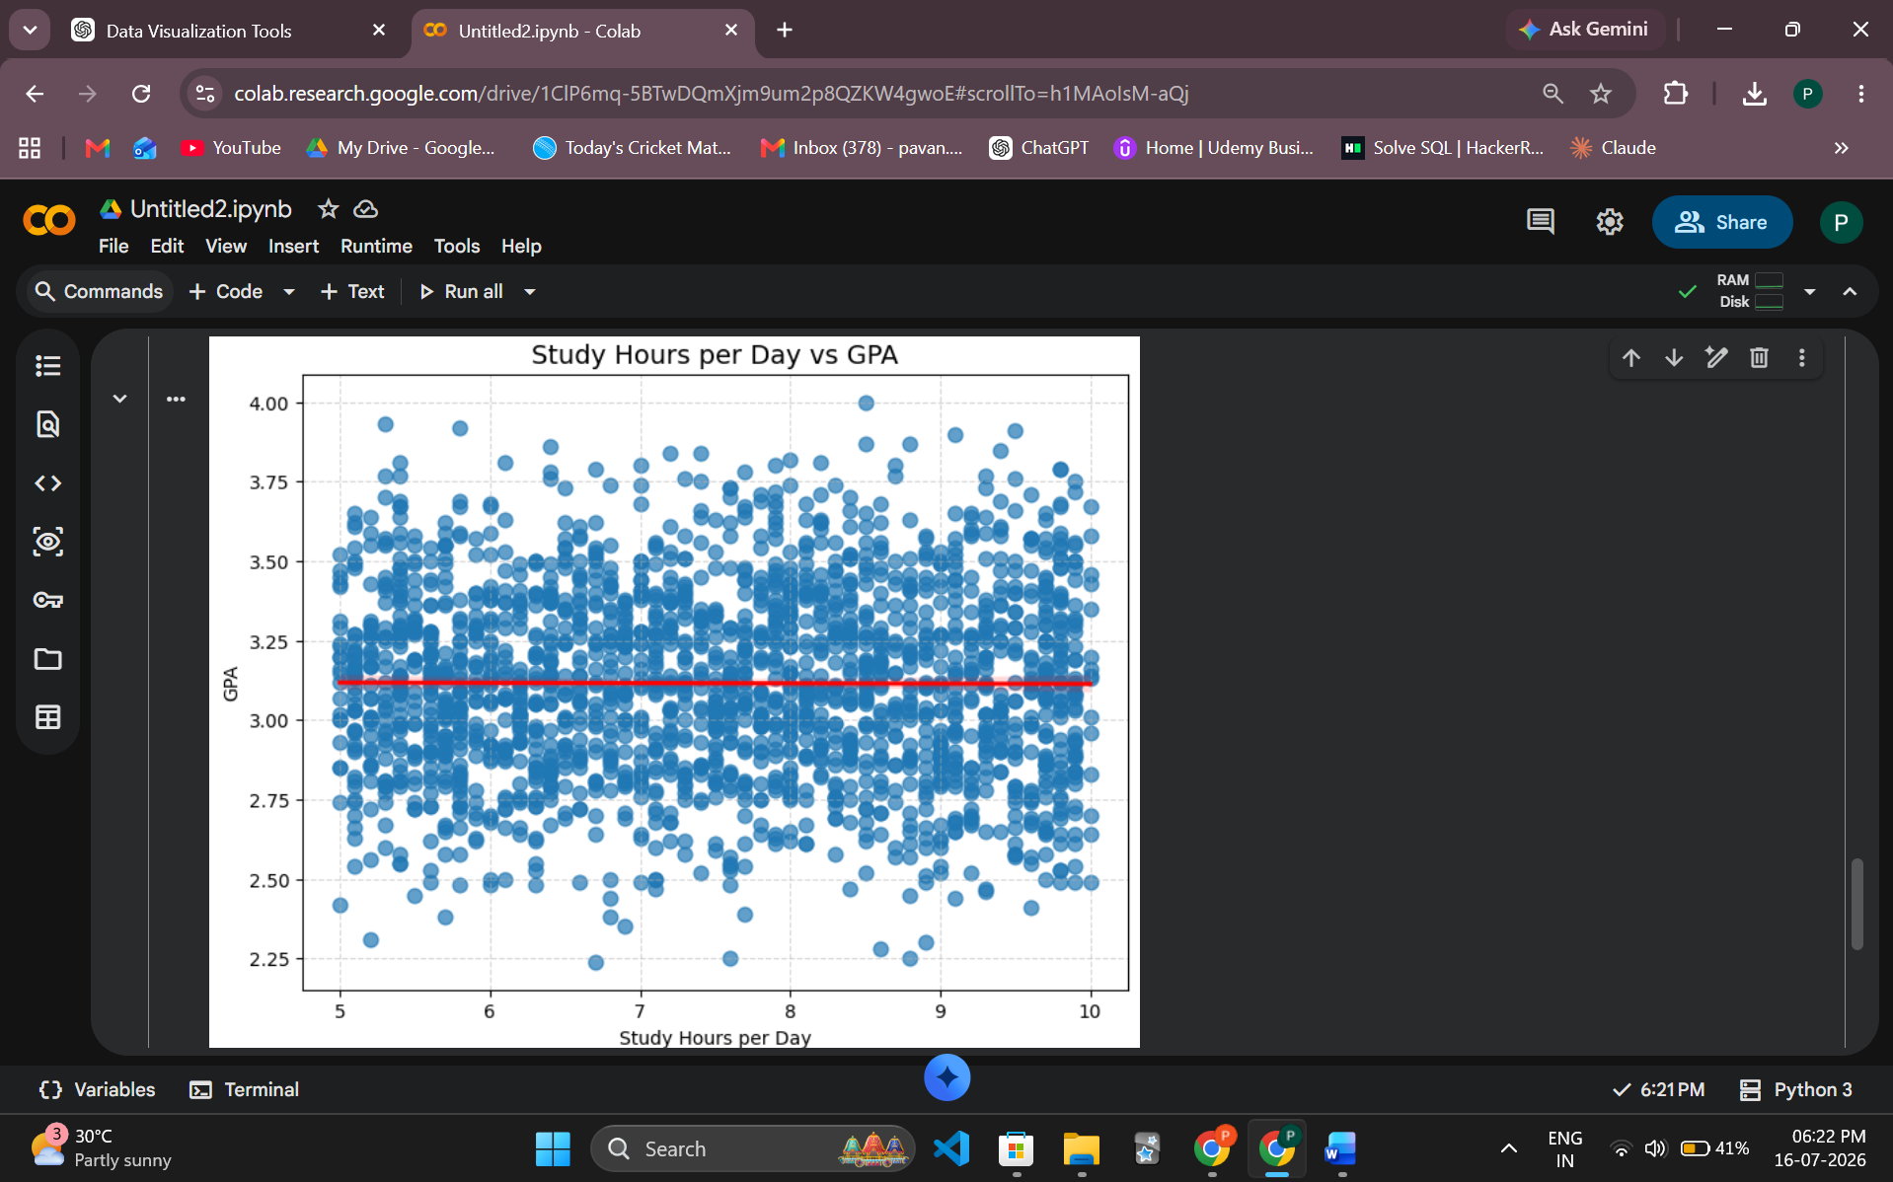
Comparison with Power BI
Unlike Power BI, Python is not a Business Intelligence platform. Instead, it offers complete programming flexibility for data cleaning, analysis, machine learning, and visualization. While Power BI excels in dashboard creation, Python is better suited for statistical analysis and predictive modeling.
Advantages
- Completely free and open source
- Highly customizable
- Excellent for machine learning
- Large ecosystem of libraries
- Integrates with AI and deep learning
Disadvantages
- Requires programming knowledge
- More time-consuming than drag-and-drop tools
- No built-in dashboard environment
- Visualizations require coding

- Microsoft Excel
History
Microsoft Excel was introduced in 1985 and remains one of the most widely used spreadsheet applications worldwide. Although originally designed for calculations and data management, it now provides numerous visualization and analytical features through Pivot Tables, Pivot Charts, and advanced chart types.
Dataset Used
For Excel I have the superstore dataset which Sir himself had shared on Kaggle. This is a very versatile dataset and contain columns which can be used for visualizations very easily, like the region and sales columns. It contains order-level information such as sales, profit, quantity, discount, customer segment, product category, region, and order dates. The dataset enables analysis of sales performance, profitability, regional trends, and customer purchasing behavior, making it a popular choice for dashboard creation and business analytics.
Visualization
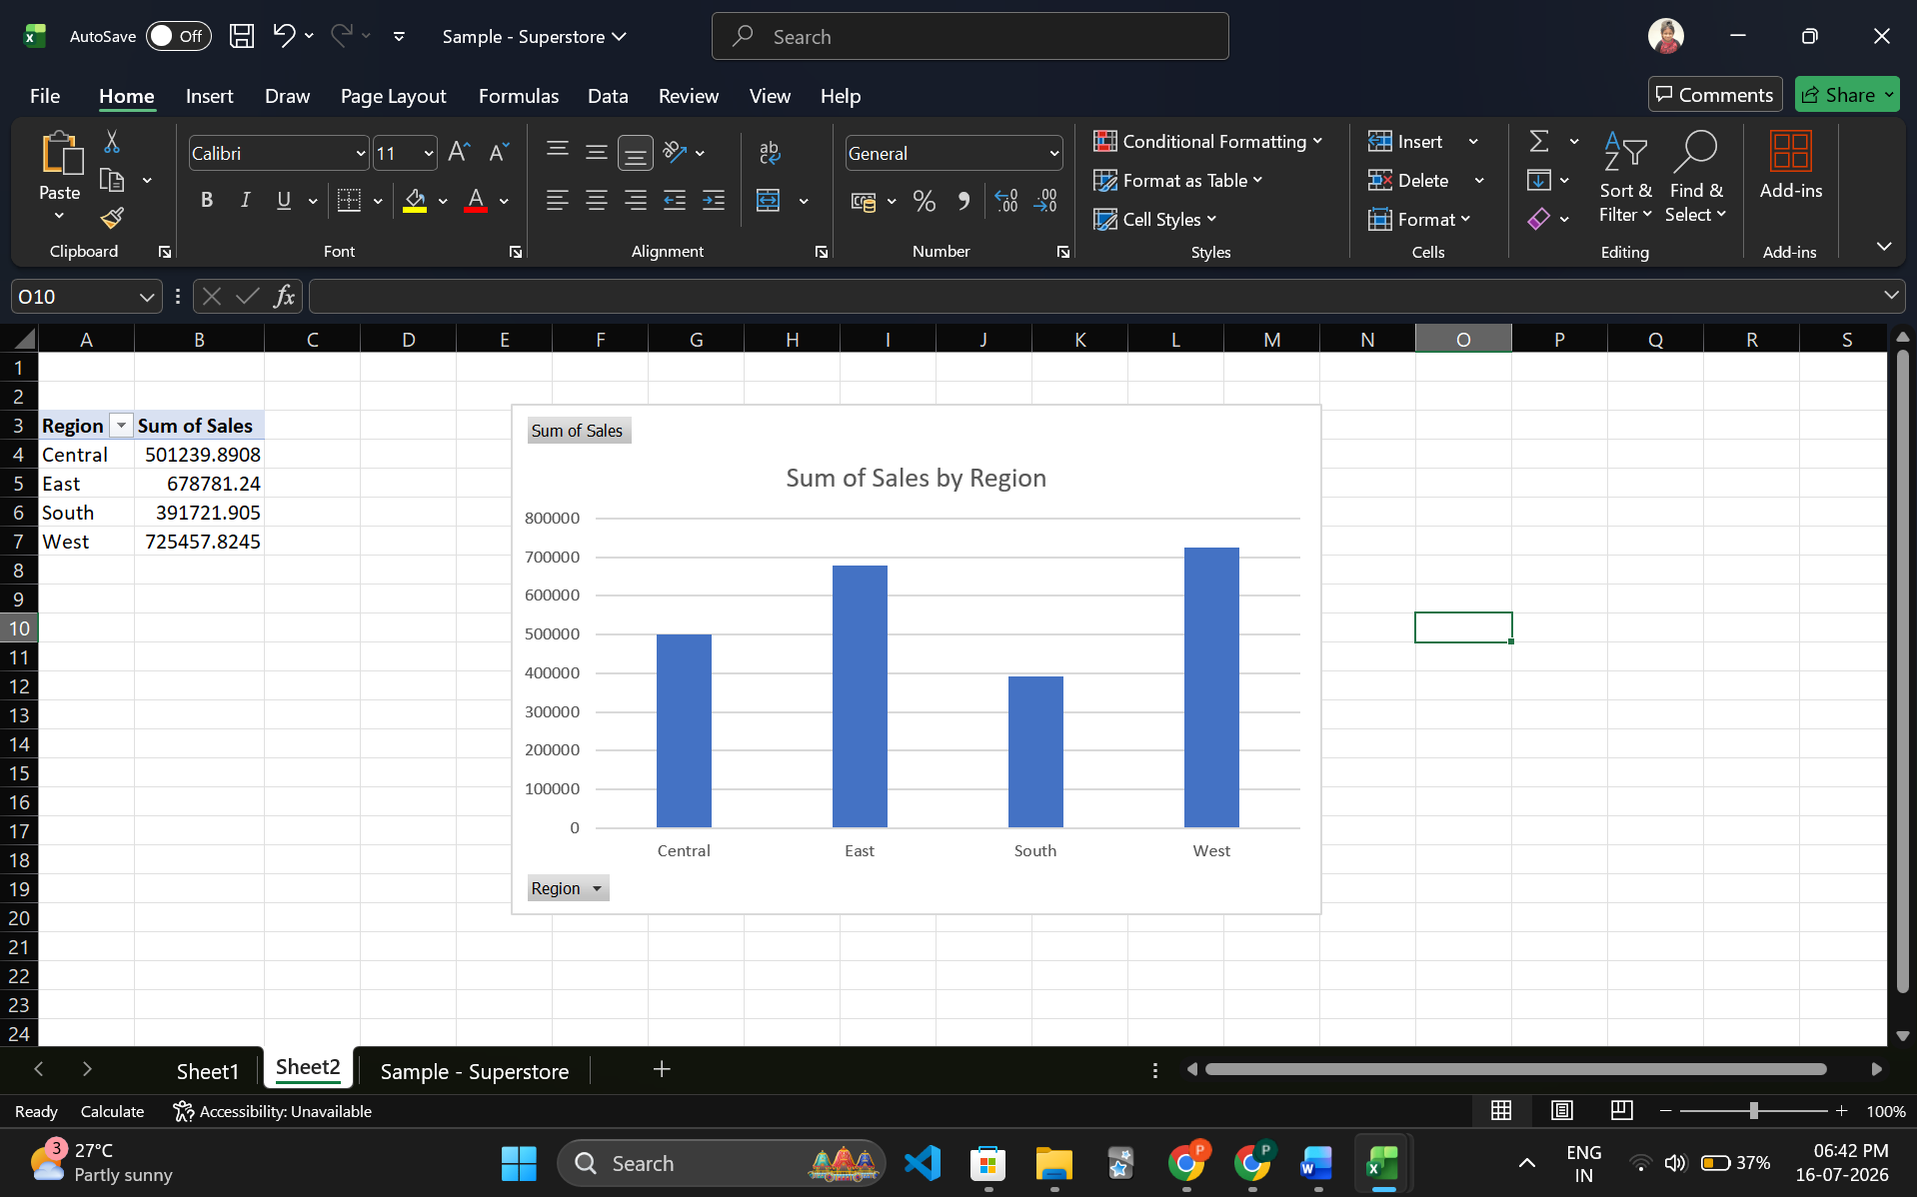
Comparison with Power BI
Excel is ideal for quick data analysis and smaller datasets, whereas Power BI is designed for large-scale business intelligence and interactive dashboards. Since both are Microsoft products, they integrate seamlessly with each other.
Advantages
- Easy to learn
- Widely available
- Excellent spreadsheet functionality
- Powerful Pivot Tables
- Suitable for quick analysis
Disadvantages
- Limited scalability
- Not ideal for very large datasets
- Less interactive than Power BI
- Dashboard capabilities are limited

- Google Looker Studio
History
Originally launched as Google Data Studio in 2016, the platform was rebranded as Google Looker Studio in 2022 after Google's acquisition of Looker. It focuses on creating cloud-based dashboards that integrate seamlessly with Google's ecosystem.
Dataset Used
For google looker studio I have used the netflix titles dataset on Kaggle. It provides information about content available on Netflix, including movies and television shows. It contains attributes such as title, type, director, cast, country, release year, duration, rating, and genre. The dataset is useful for exploring Netflix's content library, identifying trends in content production, and analyzing the distribution of genres and audience ratings.
Visualization
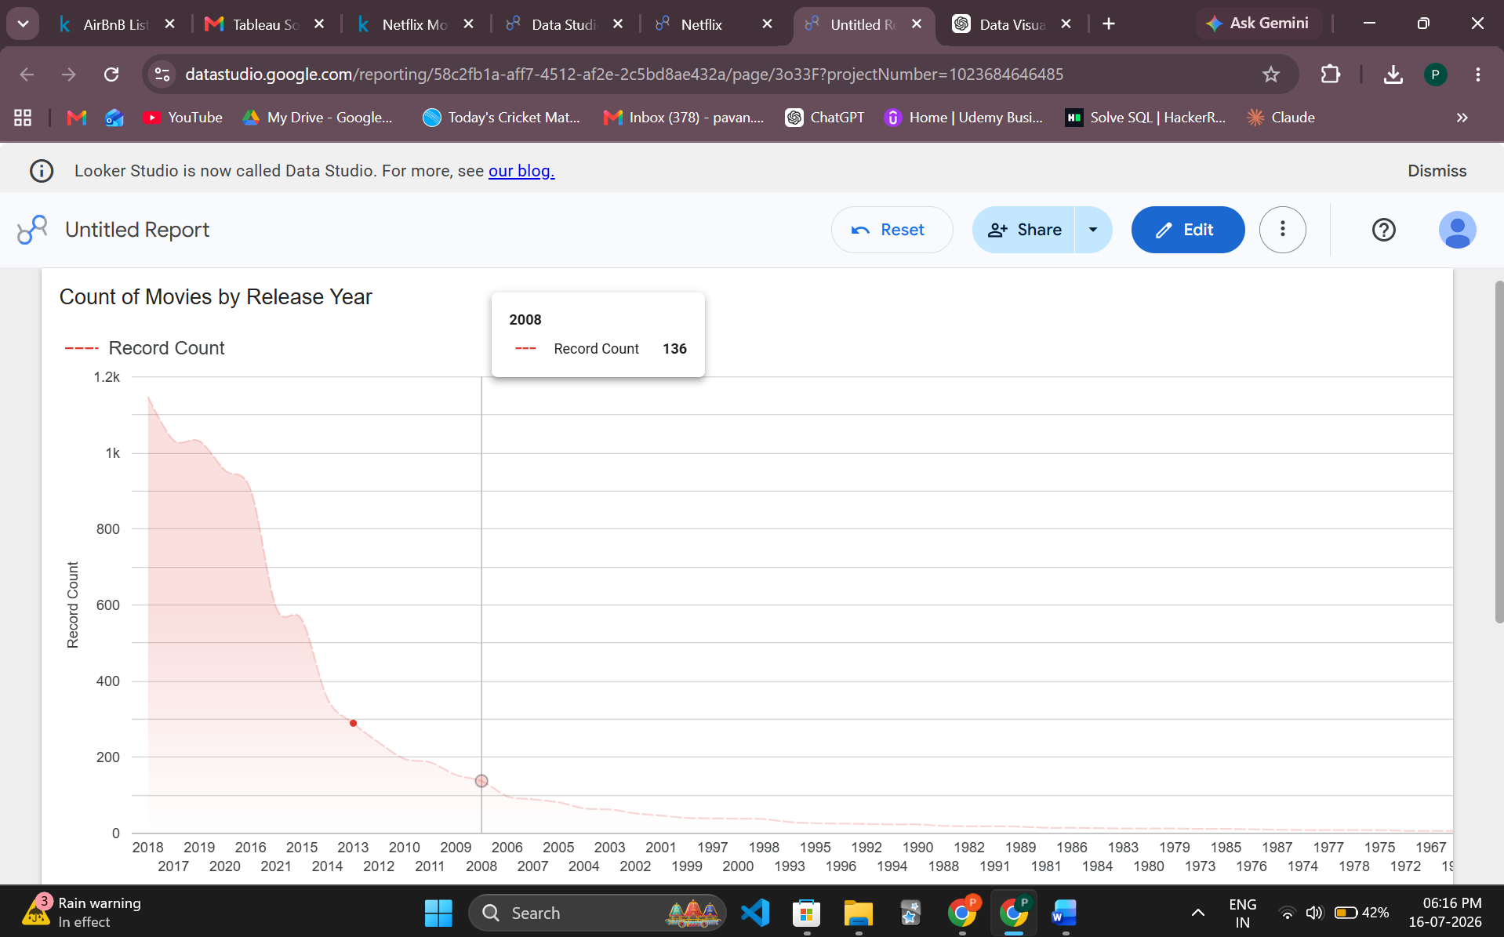
Comparison with Power BI
Power BI offers more advanced data modeling and enterprise-level analytics, while Looker Studio emphasizes simplicity, cloud collaboration, and seamless integration with Google services. However it is still difficult to navigate and lags when large datasets are uploaded. As a first time user the UI also was hard to follow.
Advantages
- Completely cloud-based
- Free to use
- Easy sharing and collaboration
- Excellent Google integration
- Interactive dashboards
Disadvantages
- Limited advanced analytics
- Fewer visualization options
- Data modeling is less powerful
- Performance decreases with complex reports

- Flourish Studio
History
Flourish Studio is a cloud-based data visualization platform introduced in 2018. It became popular among journalists, researchers, and media organizations for creating animated, interactive, and storytelling-oriented visualizations with minimal coding.
Dataset Used
For Flourish Studio I have used the superset dataset aswell but the visualizations are different. It contains order-level information such as sales, profit, quantity, discount, customer segment, product category, region, and order dates. The dataset enables analysis of sales performance, profitability, regional trends, and customer purchasing behavior, making it a popular choice for dashboard creation and business analytics.

Visualization
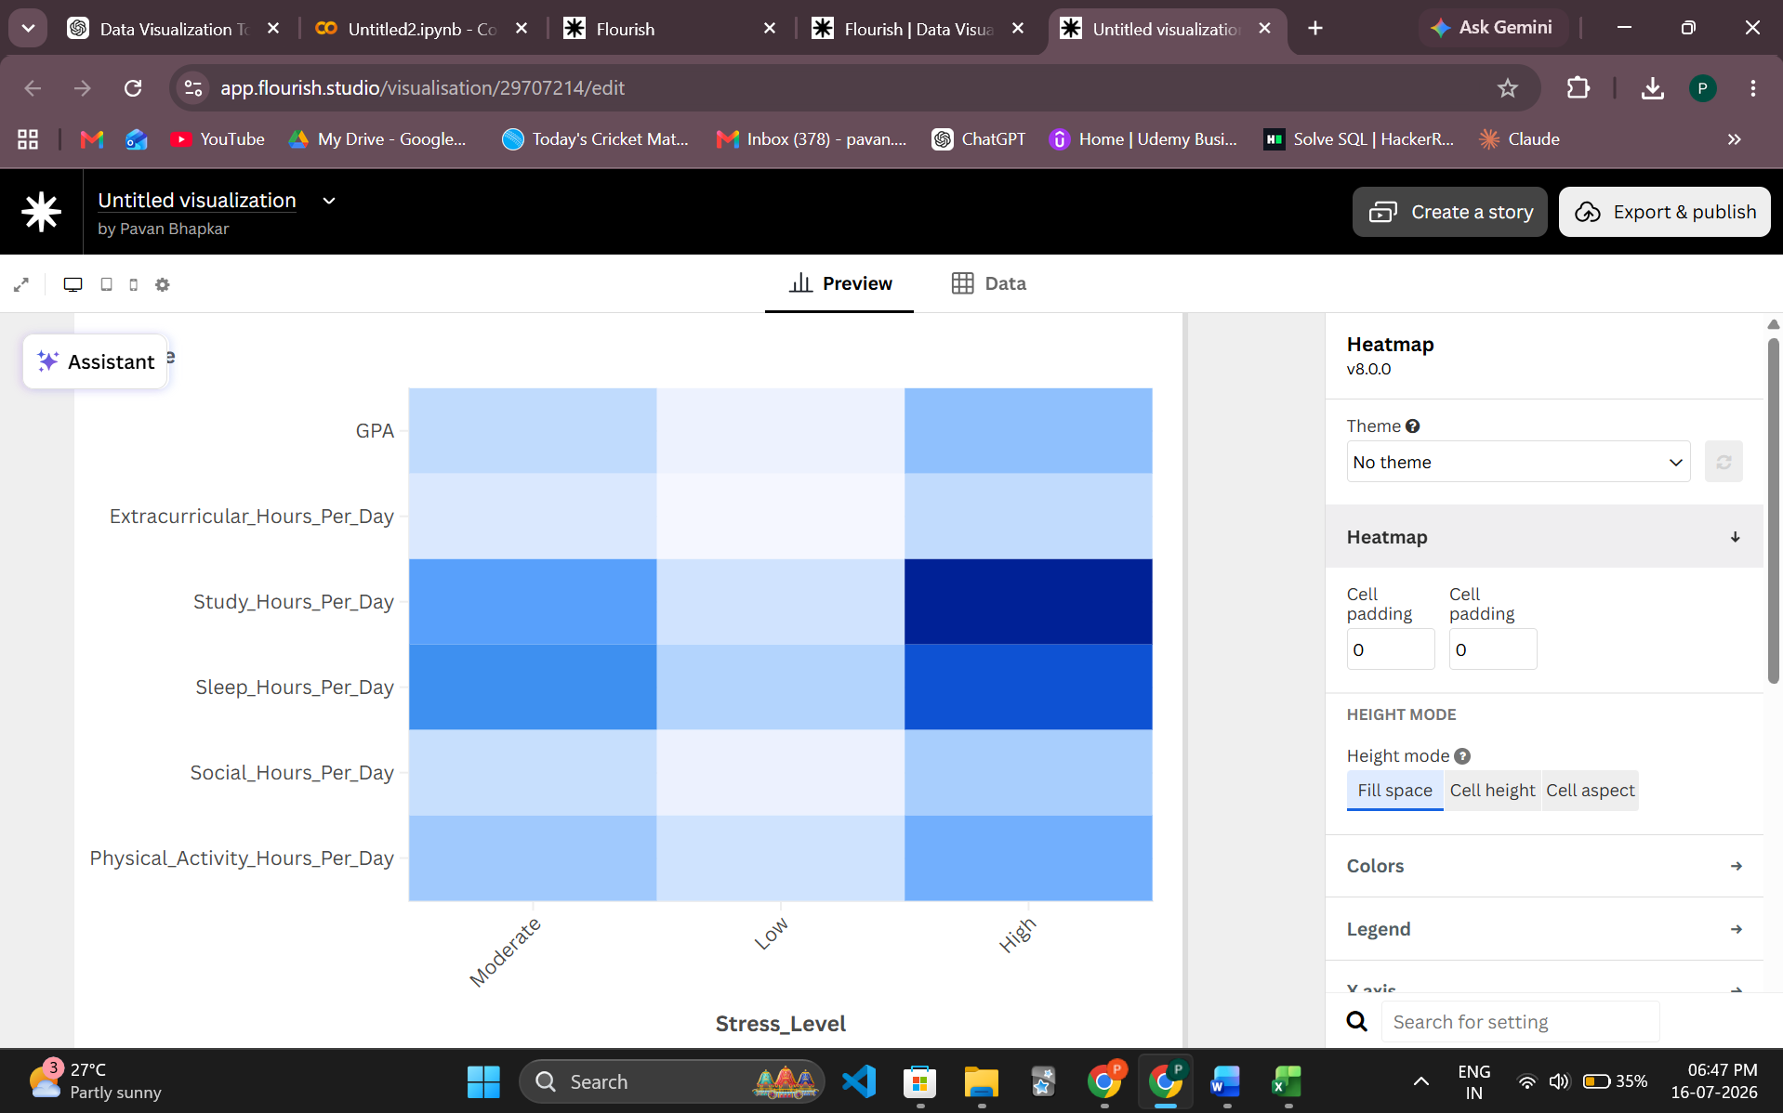
Comparison with Power BI
Unlike Power BI, Flourish focuses primarily on storytelling rather than business intelligence. It excels at creating visually appealing and interactive charts suitable for presentations, websites, and news articles.
Advantages
- Beautiful interactive visuals
- Easy to use
- Excellent animation support
- No coding required
- Embeddable in websites
Disadvantages
- Limited business intelligence features
- Fewer data transformation capabilities
- Free version includes branding
- Less suitable for enterprise reporting

Conclusion
Currently, there exist a lot of visualization tools. However, from an academic point of view, Power BI and Tableau stand out to be the best tools to learn in 2026. Both of them will be present in almost all of the job descriptions of a data analyst. Each visualization tool offers unique strengths depending on the analytical requirements. From a learning point of view one should explore all of these tools and try answering the question: “What is this dataset telling me”. The choice of visualization tool should depend on the nature of the project, the size and complexity of the data, and the intended audience. By understanding the strengths and limitations of each platform, analysts can select the most appropriate tool to effectively communicate insights and support data-driven decision-making.

Link for GitHub

